Assignment #8 Exploring Mapping by Joshua Troup

Proportional Symbol Maps (show quantitative values)

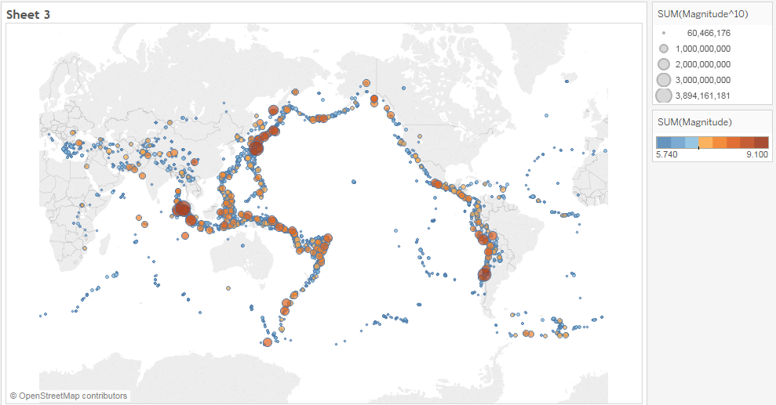

Choropleth maps (filled maps)

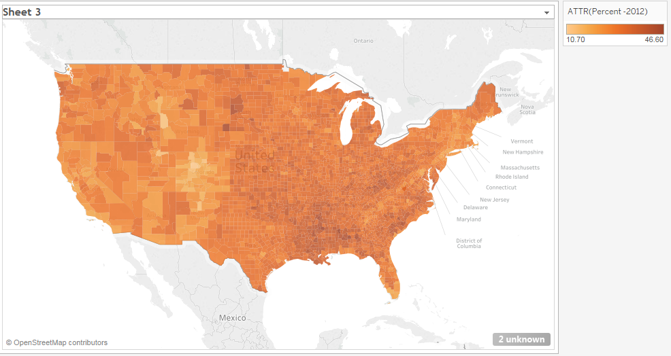

Point distribution maps (highlight visual clusters)

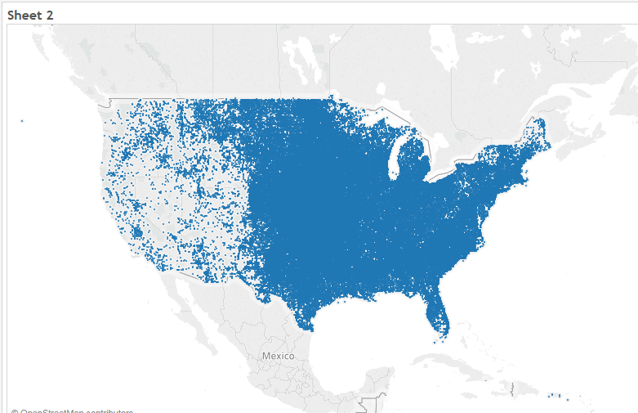

Flow maps (path maps)

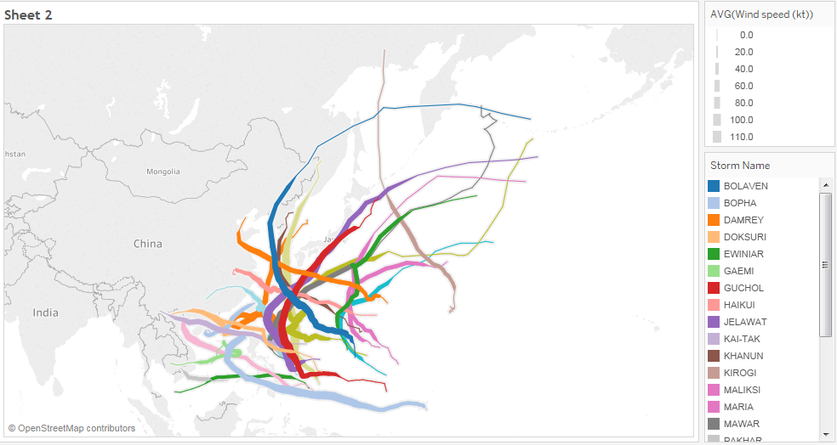

Spider maps (origin-destination maps)

